Simulated prices
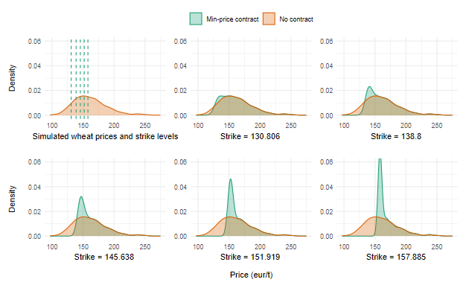

Contract design
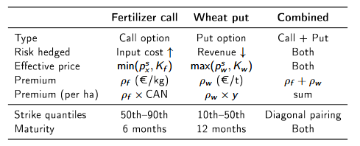

Contract price
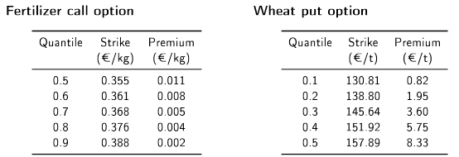

Profits formulas
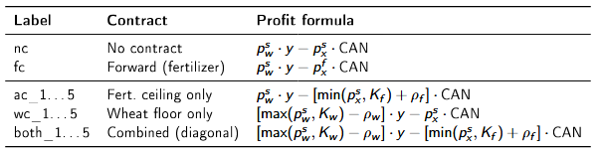
Profit summary statistics
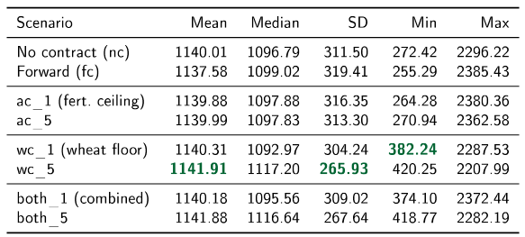
Wheat floor:
- raises minimum profit
- SD reduced
- Combined contract similar but less effective
Broad framing
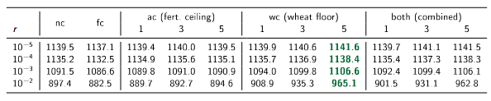
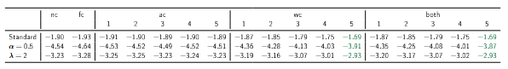
Narrow framing
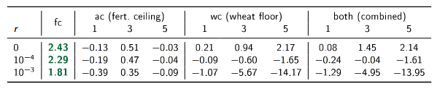
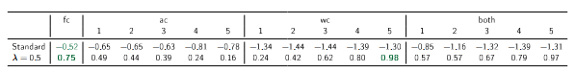
Results
